Personal Portfolio Website – Explanation, Features, and Development
Your uploaded code is a Personal Portfolio Website created using HTML and CSS only. It presents a person's profile, educational qualifications, technical skills, projects, hobbies, achievements, resume, and contact information.
The website is designed with a modern layout, colorful cards, animations, responsive navigation, and interactive effects.
1. Explanation of the website
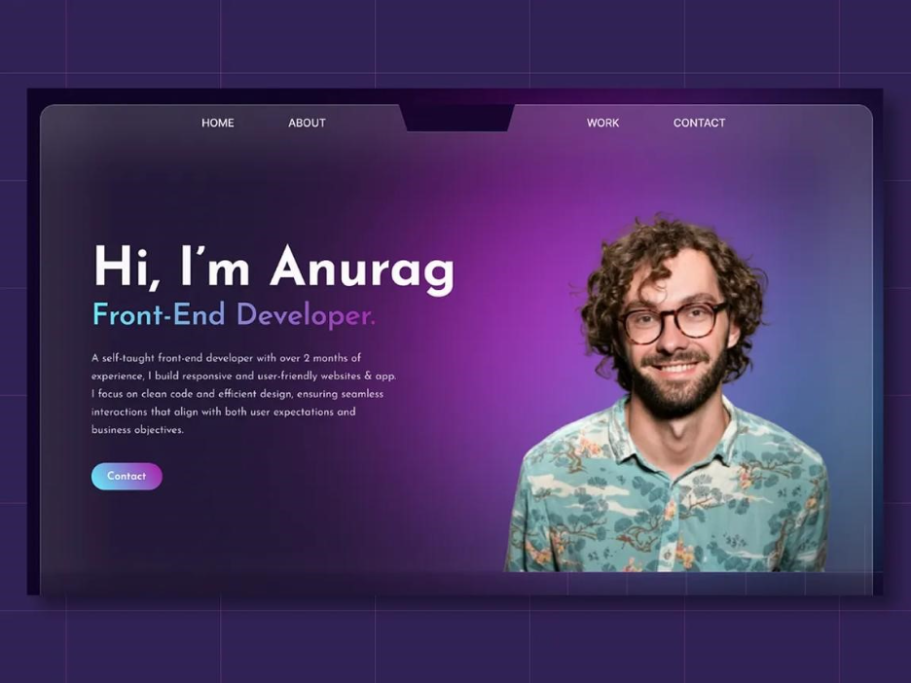
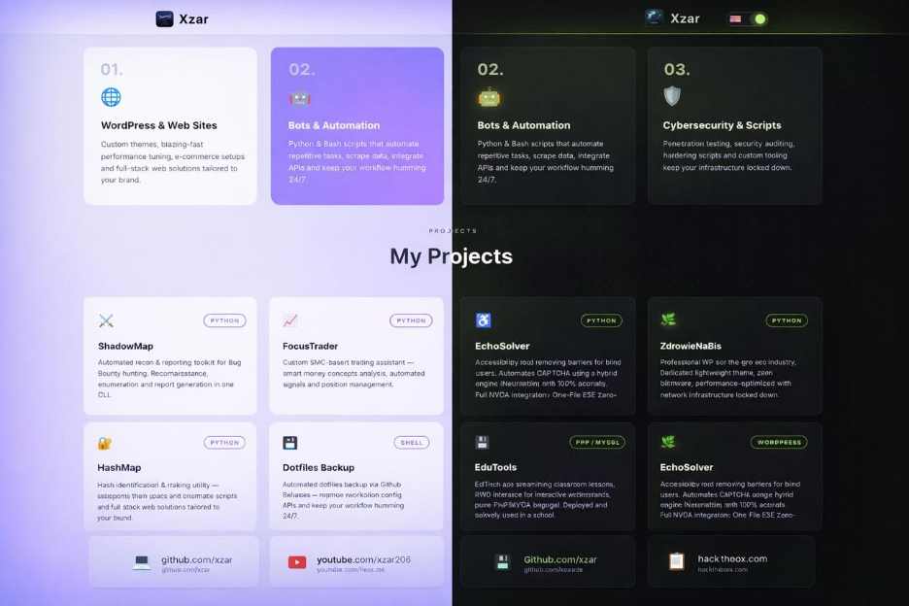
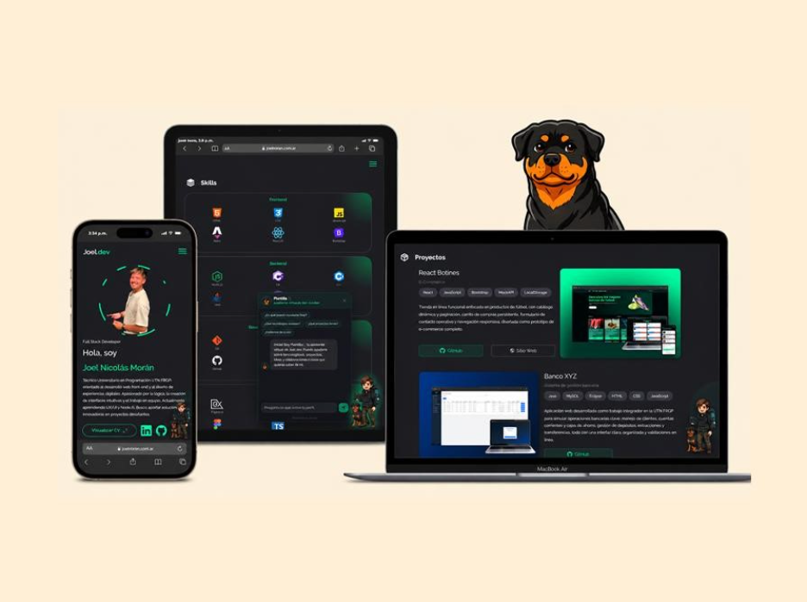
12
The website is divided into nine main sections.
1. Home
Introduces the person with their name, profession, short description, animated typing text, and buttons to view projects or contact them.
2. About Me
Displays a short biography, location, course, area of interest, and internship availability.
3. Educational Qualifications
Displays B.Tech, Intermediate, and school details using a timeline layout.
4. Technical Skills
Shows skills such as HTML, CSS, JavaScript, Python, Java, SQL, Git, and GitHub using animated progress bars.
5. Projects
Displays project cards such as Campus Marketplace, Study Planner, Rainfall Insights, and Portfolio Kit. CSS radio buttons filter the projects by category.
6. Hobbies
Shows hobbies such as photography, guitar, chess, travelling, and reading.
7. Achievements
Presents awards, scholarships, certifications, and open-source contributions.
8. Resume
Contains expandable sections for experience, education, and skills, along with a resume download link.
9. Contact
Provides email, phone, GitHub, LinkedIn, and a contact form for visitors.
Note: The name, marks, achievements, contact details, and experience shown in the code are sample portfolio content. Replace them with accurate details before publishing the website.
2. Features of the website
Feature | Explanation
Responsive design | Adjusts the layout for desktop, tablet, and mobile screens.
Sidebar navigation | Helps visitors move between sections easily.
Smooth scrolling | Moves smoothly to a selected section.
Typing animation | Displays the profession with a typing effect.
Floating animation | The circular profile initials move up and down.
Hover effects | Cards, buttons, icons, and links change when hovered over.
Animated skill bars | Skill progress bars fill with animation.
Project filtering | Filters projects into Web, Apps, and Data categories without JavaScript.
Expandable resume | Opens and closes resume details when clicked.
Contact form | Collects a visitor's name, email, and message.
Light and dark themes | Supports dark mode through CSS theme preferences and settings.
Accessibility | Includes labels, keyboard focus indicators, and reduced-motion support.
3. Development of the website
The website is developed using two technologies.

HTML — Structure
HTML creates the content and sections, including headings, paragraphs, links, cards, forms, and navigation.

CSS — Design
CSS controls colors, layouts, spacing, typography, animations, responsiveness, and interactive visual effects.
Step-by-step development process
- Create the HTML structure. Start with <!DOCTYPE html>, <html>, <head>, and <body> tags.
- Add navigation. Create links using <nav> and anchor tags such as <a href="#skills">Skills</a>.
- Create the sections. Add Home, About, Education, Skills, Projects, Hobbies, Achievements, Resume, and Contact using <section> elements.
- Apply CSS styling. Use colors, fonts, margins, padding, borders, and rounded corners to create a neat appearance.
- Add animations. Use @keyframes, transition, and transform for typing, floating, hovering, and skill-bar effects.
- Make it responsive. Use @media queries to change the navigation and layout for smaller screens.
- Add CSS-only interactions. Use radio buttons to filter projects, checkboxes for the mobile menu, and <details> and <summary> for expandable resume information.
- Test the website. Save the file as index.html, open it in a browser, and check the links, layout, animations, and forms.
4. Important code explanations
These are the main CSS and HTML techniques used in your uploaded code.
A. Smooth scrolling
html {
scroll-behavior: smooth;
}
Explanation: When a visitor clicks a navigation link, the browser scrolls smoothly to the selected section instead of jumping immediately.
B. Responsive layout
@media (max-width: 860px) {
main, footer {
margin-left: 0;
}
}
Explanation: When the screen width is 860 pixels or less, the main content and footer no longer reserve space for the desktop sidebar. Other CSS rules in the same media query turn the sidebar into a collapsible mobile menu.
C. Animation
@keyframes float {
50% {
transform: translateY(-18px);
}
}
Explanation: The circular profile element moves upward by 18 pixels halfway through the animation, creating a floating effect.
D. Hover effect
.card:hover {
transform: translateY(-5px);
}
Explanation: When the visitor moves the mouse over a card, it moves upward by five pixels. The full code also adds a border-color change and shadow.
E. CSS-only project filtering
<input type="radio" name="f" id="f-web">
<label for="f-web">Web</label>
#f-web:checked ~ .grid .p:not(.web) {
display: none;
}
Explanation: Selecting the Web filter hides project cards that do not have the web class. The same technique is used for Apps and Data. This interaction does not require JavaScript.
F. Expandable resume
<details>
<summary>Education</summary>
<div>
<p>B.Tech, Computer Science</p>
</div>
</details>
Explanation: Clicking Education opens or closes the associated information. HTML provides this interaction without JavaScript.
5. How the website works
HTML file
Content and structure
CSS styles
Design, layout, and animations
Web browser
Combines HTML and CSS to display the website
The browser reads the HTML structure, applies the CSS styles, and displays the portfolio. CSS also handles many of the website's interactive effects.
6. Important limitations
- No JavaScript: The website uses HTML and CSS only, so it cannot provide JavaScript-based functionality.
- Contact form: The form uses mailto: to open the visitor's email application. It does not send messages directly through a website server.
- Resume download: The resume.pdf file must exist in the correct location for the download link to work.
- Sample information: Replace the example name, educational details, skills, achievements, and contact information with your own.
- Dark mode: The code supports automatic dark mode and a CSS theme attribute, but it does not include a visible button to switch themes.
- Project filtering: Filtering works entirely through CSS radio buttons, not JavaScript.
7. Conclusion
This project demonstrates how to build an attractive, responsive personal portfolio using HTML and CSS without JavaScript. It combines semantic HTML, modern CSS layouts, animations, hover effects, responsive design, and CSS-based interactions to present professional information in an organized way.
The website can be used as a personal portfolio, college mini-project, or starting point for a professional portfolio.

